First start the server:-

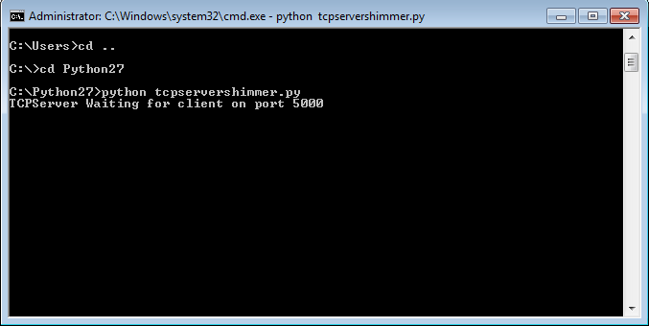

Once the server is started open the ShimmerTCPExample Android application on your Android device. Once the Shimmer device starts streaming you should see the following:-

